Troubleshooting Video Issues
If you’re having trouble viewing or hearing multimedia in your classes please check the troubleshooting tips below.
If you continue you to have problems with accessing audio or video please contact cyberhelp@ggu.edu and we’ll get back to you within 24 hours on Mondays-Fridays.
Media Players
Media players have frequent updates to address bugs and security issues. Make sure you have the latest free players. Here are some links to players most frequently user in CyberCampus. After you download the player make sure you install it as well. During installation careful watch to make sure you don’t download any elements, like “WeatherBug” or “Norton Security” that you may not want – just uncheck boxes if these additional elements are offered.
Browsers
Make sure that you are using an up-to-date browser.
Browser Security
Media objects in CyberCampus are safe (although remember to always have some sort of security in place on your computer for your protection) but sometimes the newest browser protocols err on the side of caution and will want additional actions on your part before displaying the media.
Firefox:
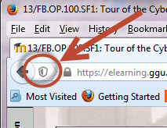
If you’re not seeing video or some other piece of content in a class and you’re using Firefox take a look to the top left of the web address. If there is a shield there click on the shield. The shield will say that some content is insecure, and ask if you want to “Disable Protection on This Page”. Select to disable protection on the page in order to display the missing piece. It sounds scary to disable protection but the videos, and other content, on CyberCampus are quite safe.
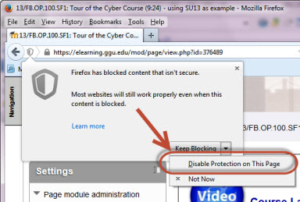

Browser Security (cont.)
Chrome and Internet Explorer:
In Chrome and Internet Explorer you may run into a similar situation where content is not displaying. Much like Firefox, take a look in the area where the web address is. There may be a shield icon or a message to the left, right, or directly underneath the web address that requires you to select to see the additional content. You should elect to see the content.

Firewalls:
Some institutions, especially workplaces, have firewalls in place to discourage employees from seeing certain online content – especially videos. If you can see a video at home, but not at work, you may want to ask your IT staff if it’s possible to unblock sites related to http://elearning.ggu.edu so you can view them at your workplace.
Narrow Down the Problem:
Another computer: If you can’t see a video, audio or other class element try another computer such as a co-worker’s computer, a computer at the library, a work or home computer, your child’s computer. If you can see it on another computer it helps to know that the situation is contained just on your computer and that is good information for the helpdesk to know.
Another browser: If you can’t see a video, audio or other class element try another browser to see if you have better luck. If it works on another browser then you’ve narrowed down that there is a setting or version issue with at least one browser.
Ye Olde Reboot:
With computer problems that are hard to solve it’s always a good idea to reboot and see if that corrects the situation. It’s annoying, but it works about 25% of the time if all other options are exhausted.
Hey, That Still Doesn’t Work. Help!
If the above steps don’t work don’t suffer in silence: Email cyberhelp@ggu.edu. In the email provide as many details and hints as you can. What’s your name? In what class and week is the problem content? Who is your instructor? Are you getting some type of error message? Are you not seeing anything? Have you tried another computer or another browser? Have you updated your browser and media players? What browser are you using? We will investigate and cyberhelp@ggu.edu will get back to you, generally within 24 hours, M-F 9-5 when you have a sticky audio/video question.

